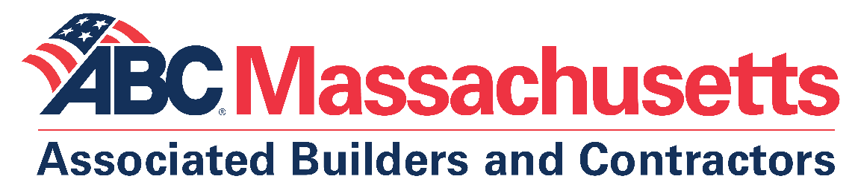

Excellence in Construction Awards - Tips for Success

- Read instructions.
- Follow directions.
- Do not exceed word limits.
- Pay attention to clarity/specific language.
- Proofread - avoid typos and grammatical errors.
- Keep the focus on the project and the work performed, not on marketing your
company.
- Provide specific examples, not generalizations. NO: There were scheduling
challenges. YES: The schedule was cut by two weeks just prior to our commencing on-site work.
- Avoid clichés. NO: This project allowed us to shine. YES: This project allowed our project managers and field personnel to demonstrate flexibility and ingenuity in meeting unforeseen conditions and a reduced schedule.
- Include work-in-progress photos.
- Have a strong endorsement letter from the owner/GC (if sub entry).
- Call ABC at 781-273-0123 if you have any questions (or email greg@abcma.org
- or carol@abcma.org). We're here to help!

